How money changed the big 6 in Premier League?

Nguyen Huu Hanh

The Premier League is often regarded as Europe's top football league. Each match in the league receives over one million viewers, and some of the most important matches, known as derby games, can receive up to five million viewers. In practically every game, attendance in the English Premier League is at capacity. Yet, the Premier League's current standing is relatively new. Before, the best football leagues were believed to be Serie A in Italy and La Liga in Spain. Then what drives the Premier League to the top? There are numerous reasons for this, but the focus of this article will be on money - how big clubs in England spend and get the best players to come to the league and make it more entertaining to watch.

Hypothesis:

In this report, we attempt to tackle the question of whether money may make it easier for English clubs to win trophies. We only keep track of Premier League titles.

Method:

To clean the data and retrieve the information, we use Python and the Pandas library. This report is divided into two sections. The first section compares the performance of the top six clubs over two time periods: 2000-2010 and 2010-2021. This two time periods depict the Premier League before and after it was the best football league. The second chapter will look at how the big 6 clubs perform in the transfer market and whether it helps them win titles.

Source:

The Premier League table from 2000-2021 was sourced from kaggle. The Premier League transfermarkt was sourced from Transfermarkt.

Analysis:big 6 performance

Now, let's look at which clubs won the most titles between 2000 and 2010. During this time, the Premier League was not regarded the best football league in Europe, but it was a top five league.

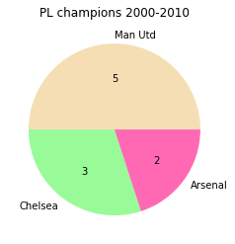

As you can see, the Premier League was won by only three teams. Manchester United, Arsenal, and Chelsea were all present. Only Manchester United and Arsenal were regarded "major clubs" in England, and they were part of the so-called "big four." Even before the Premier League was established, the big four were the four clubs who had won many titles in the English top flight. Chelsea was not considered a big four club until it was purchased by Russian businessman Roman Abramovich. He had spent a lot of money into the team in order to compete against the "big four," and success was achieved.

To see if the clubs that won the league from 2000 to 2010 were truly dominant, consider how many goals they scored.

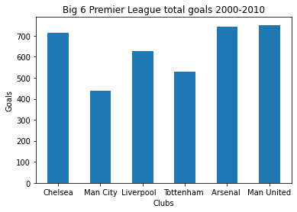

Three clubs who have won the championship have also scored the most goals. Yet, the difference is not significant. Spurs and Liverpool, the other two clubs in the big four category, were also in the top five.

Let's take a look at the Premier League from 2010 through 2021. This is the time of year when the Premier League attracts the most viewers and money.

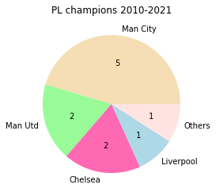

As you can see, Manchester City has won the most titles (6 in total), considerably surpassing Manchester United and other clubs. In comparison to 2000-2010, 5 clubs have won titles, indicating that the league is more competitive. Let's see how many goals the best teams can score.

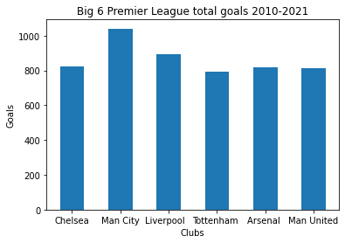

Manchester City is far ahead of the other major four clubs in the league with over 1000 goals. Nonetheless, there is little distinction between other major clubs. This demonstrates that the quality of the remaining top six clubs is similar.

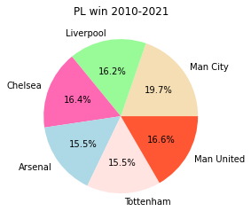

Manchester City has the most wins in the league because it has the most wins. Manchester City, however, does not dominate when compared to other major English clubs. This demonstrates that the Big 6 is extremely competitive from 2010 through 2021.

Manchester City is another good example of outside financiers pouring money into the club. Abu Dhabi United Group purchased the club in 2008 and developed it into one of the most powerful teams in England and Europe. Because the Premier League is so appealing, big teams have engaged in a "arms race," aiming to buy the top players with the biggest bid. Following the recent success of Manchester City and Chelsea, they were added to the major club category and are now regarded as the "big 6" in England.

Deeper analysis

We are now digging deeper into how England's big six clubs invest. We can answer our hypothesis using this deeper analysis part.

Let's take a look at how big 6 spend their money from 2000 to 2010. Chelsea has become the top spender in the transfer market since Ambramovich took over. Chelsea's overall spending exceeded 800 million euros, accounting for more than 12% of the Premier League's total spending. Chelsea has been transformed into a so-called "big club" with significant cash injections, despite the fact that Chelsea was recognized as a historical club in London. Chelsea had the chance to be more competitive in the transfer market, with the influence to sign great coaches like Jose Mourinho and Carlo Ancelotti. The club went on to win three titles, trailing only the great Manchester United. The disparity between Chelsea's overall spending and that of other major teams is significant, particularly when compared to Arsenal.

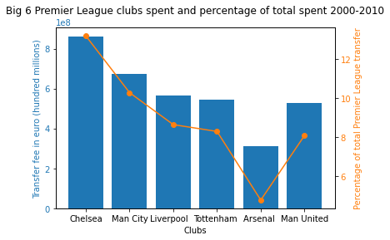

We will now examine net spending to determine the difference between buying and selling of each clubs. Chelsea is the biggest net spender not only in big 6 clubs but also the entier Premier League. This is compatible with the fact that Chelsea was rebuilding from 2000 to 2010. Incoming players were significantly more expensive than departing players. These newcomers would also play an important role in Chelsea's future, growing increasingly valuable to the club as it won titles. Manchester City followed Chelsea's approach and began revamping their lineup following Abu Dhabi's takeover. This helps to understand why Chelsea and Manchester City had the highest net spending.

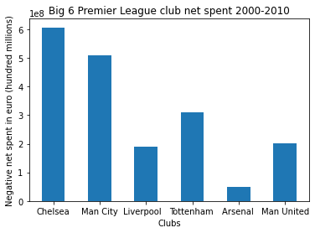

The transfer market expanded dramatically at the start of the new decade. This could be because there are many talented players, teams are more profitable, and broadcast and brand deals are more lucrative. As the best football league in the world, the Premier League also has some of the biggest spenders in the transfer market.

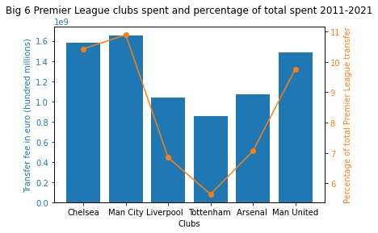

Following Chelsea's transfer market success, the big six clubs are willing to spend just to be more competitive in terms of achievements and heritage. With the help of the Abu Dhabi Group, Manchester City has become the largest spender from 2011 to 2021. With one of the best football coaches in the world, Pep Guardiola, the club has attracted some of the biggest football stars, including Sergio Aguero, Kevin de Bruyne, and Jack Grealish. When the amount Manchester City has spent is compared to the club's achievements, it shows the club's massive growth from mediocre to best in the world. This 'arms race' did not end with Manchester City; almost every club, including the remaining big six, was vying for talented players. Chelsea and Manchester United were also huge spenders, but they trailed Manchester City slightly. Although though Chelsea had some success, Manchester United was the biggest disappointment. Manchester United won two titles between 2011 and 2021, however it was under Sir Alex Ferguson and with nearly the same core players who had previously won titles. When Sir Alex left and many old players retired from football, the club began to rebuild. Nonetheless, despite spending nearly 1.5 billion euros on rebuilding, Manchester United has yet to win a trophy. In comparison to Manchester United, Liverpool has won six trophies, including one Premier League title, while spending far less. Arsenal and Tottenham have both increased their spending but have yet to win the Premier League.

The net spend chart from 2011 to 2021 depicts another aspect of big 6 spending. Manchester City follows in the footsteps of Chelsea over the last decade, being the largest net spender because the old players were not as valuable as the new players. Chelsea, on the other side, is just fourth. The players that the club purchased during the last decade proved to be quite valuable, which benefitted Chelsea. Manchester United's second-largest net spender demonstrates once again that money alone cannot win trophies. Liverpool is a great example of this; much of the club's success can be attributed to Jurgen Klopp's playstyle and the acquisition of the right player for the playstyle.

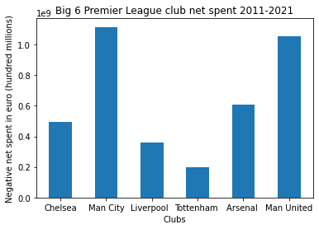

Conclusion

According to the analysis, money has played a significant role in the success of some clubs, particularly Chelsea and Manchester City. Money allows the Big Six to acquire good players, hire new coaches, and modernize facilities. As a result, money may make it easier for the team to win titles. Nevertheless, how to win championships is a another matter. When it comes to success, using money properly and effectively is critical. Manchester United has spent roughly the same amount as Manchester City but achieving far less. Liverpool may win the title while being frugal. This report falls short of analyzing other elements that may have an impact on the club's success. Yet, this analysis highlights the importance of money in big 6 growth and success, making the league more competitive.